AUTOMATED ENGINEERED DOMESTIC USE AIR PURIFIER

Project report submitted in partial fulfilment of the requirement of the degree of

BACHELOR OF TECHNOLOGY

By

Lakshay Sharma (1603040046)

Rishu Sharma (1703040044)

Satyam Mishra (1703040046)

Shivam Patodia (1703040052)

Shubhank Sharma (1703040054)



#### DEPARTMENT OF MECHANICAL ENGINEERING

INDERPRASTHA ENGINEERING COLLEGE

(January, 2021)

CERTIFICATE

It is certified that the work contained in the project report titled “AUTOMATED ENGINEERED DOMESTIC USE AIR PURIFIER”

by “Lakshay Sharma (1603040046), Rishu Sharma (1403040044), Satyam Mishra (1703040046), Shivam Patodia (1703040052) and Shubhank Sharma (1703040052)” has been carried out under my supervision and that this work has not been submitted elsewhere for a degree.

Signature of Supervisor

Mr. Manoj Kumar Yadav

Associate Professor

IPEC, GZB

January, 2021

DECLARATION

We declare that this written submission represents our ideas in our own words and where others' ideas or words have been included, we have adequately cited and referenced the original sources. We also declare that we have adhered to all principles of academic honesty and integrity and have not misrepresented or fabricated or falsified any idea/data/fact/source in our submission. We understand that any violation of the above will be cause for disciplinary action by the Institute and can also evoke penal action from the sources which have thus not been properly cited or from whom proper permission has not been taken when needed.

Signature:

Lakshay Singh (1603040046) _ _ _ _ _ _

Rishu Sharma (1703040044) _ _ _ _ _ _

Satyam Mishra (1703040046) _ _ _ _ _ _

Shivam patodia (1703040052) _ _ _ _ _ _

Shubhank Sharma (1703040054) _ _ _ _ _ _

January2021

TABLE OF CONTENT

Certificate

Declaration

Chapter 1 **INTRODUCTION**

1.1 Pollution

1.2 Air pollution

1.3 Air pollution statistic

CHAPTER 2 **LITERATURE REVIEW**

**CHAPTER 3 AQI FOR DOMESTIC USE**

CHAPTER 3 **Domestic Safety levels For Gas**

CHAPTER 4 **Electronic Components**

4.1 Arduino Uno

4.2 MQ 135 Sensor

4.3 MQ 7 Sensor

4.4 DHT 11 Sensor

4.5 LCD Screen (16*2)

4.6 Block Diagram

CHAPTER 5 **Mechanical Components**

5.1 Air Cabin

5.2 Filter selection

5.3 Motor And

5.4 Centrifugal Fan

CHAPTER 6 **DESIGN OF PURIFIER**

6.1 Calculation

6.2 Overall Design

6.3 Total Expenditure

CHAPTER 7 **CONCLUSION**

REFERENCES

CHAPTER1

INTRODUCTION

* 1. POLLUTION

Pollution is the introduction of [contaminants](https://en.wikipedia.org/wiki/Contaminant) into the natural environment that cause adverse change. Pollution can take the form of [chemical substances](https://en.wikipedia.org/wiki/Chemical_substance) or [energy](https://en.wikipedia.org/wiki/Energy), such as noise, heat or light. The components of pollution, can be either foreign substances/energies or naturally occurring contaminants.

Major forms of pollution include: [Air pollution](https://en.wikipedia.org/wiki/Air_pollution), [light pollution](https://en.wikipedia.org/wiki/Light_pollution), [littering](https://en.wikipedia.org/wiki/Littering), [noise](https://en.wikipedia.org/wiki/Noise_pollution) [pollution](https://en.wikipedia.org/wiki/Noise_pollution), [plastic pollution](https://en.wikipedia.org/wiki/Plastic_pollution), [soil contamination](https://en.wikipedia.org/wiki/Soil_contamination), [radioactive contamination](https://en.wikipedia.org/wiki/Radioactive_contamination), [thermal](https://en.wikipedia.org/wiki/Thermal_pollution) [pollution](https://en.wikipedia.org/wiki/Thermal_pollution), [visual pollution](https://en.wikipedia.org/wiki/Visual_pollution), [water pollution](https://en.wikipedia.org/wiki/Water_pollution).

1.2 AIR POLLUTION

Pure air is a mixture of various gases such as nitrogen, oxygen, argon, carbon dioxide, and small number of other gases in a fixed proportion. If the composition of air alters by any means; it is known as air pollution, which can lead to effects on human health, environment, and other living creatures. According to The Air (Prevention and Control of Pollution) Act, 1981, “air pollution is the presence of any solid, liquid, or gaseous substance in the atmosphere in such concentration as may be or tend to be injurious to human beings or other living creatures or plants or property or environment”. Air pollution has now become a serious issue of concern and many of the countries in the world such as Pakistan, Iran, India, UAE, and China etc. are formulating strategies to deal with it.

1.3 Air pollution Statistic

1.3.1 WHO-World Health Organization

The World Health Organization is a [specialized agency of the United Nations](https://en.wikipedia.org/wiki/List_of_specialized_agencies_of_the_United_Nations) that is concerned with international [public health](https://en.wikipedia.org/wiki/Public_health). It was established on 7 April 1948 headquartered in [Geneva,](https://en.wikipedia.org/wiki/Geneva) [Switzerland.](https://en.wikipedia.org/wiki/Switzerland) It incorporated the [Office International Hygiene Pulque](https://en.wikipedia.org/wiki/Office_International_d%27Hygi%C3%A8ne_Publique) and the League of Nations Health Organization. Since its creation, it has played a leading role in the [eradication](https://en.wikipedia.org/wiki/Eradication_of_infectious_diseases) of [smallpox](https://en.wikipedia.org/wiki/Smallpox). Its current priorities include [communicable diseases](https://en.wikipedia.org/wiki/Communicable_disease), in particular [HIV/AIDS,](https://en.wikipedia.org/wiki/HIV/AIDS) [Ebola](https://en.wikipedia.org/wiki/Ebola), [malaria](https://en.wikipedia.org/wiki/Malaria) and [tuberculosis](https://en.wikipedia.org/wiki/Tuberculosis); the mitigation of the effects of non- communicable diseases; sexual and [reproductive health](https://en.wikipedia.org/wiki/Reproductive_health), development, and ageing; [nutrition, food security](https://en.wikipedia.org/wiki/Food_security) and healthy eating, occupational health, substance abuse, and driving the development of reporting, publications, and networking.

CHAPTER 2

LITERATURE REVIEW

2.1 **THREE LAYER AIR PURIFIER**

This was proposed by marron hack, Richmond, VA (US) in 2002.An air purifier including a housing supporting an air inlet, an air outlet and an air flow passage interconnecting the air inlet and the air outlet. The airflow passage is defined by a filtration chamber positioned upstream from a blower chamber and an ultraviolet light chamber. A blower assembly is supported within the blower chamber and includes a fan driven by a motor for forcing air through the air flow passage from the air inlet to the air outlet. A pre-filter and a main filter are removable supported within the air filtration chamber for entrapping particulates having a size of 0.3 microns and greater. An ultraviolet light source is positioned within the light chamber and is positioned proximate the air outlet. An outlet grille is supported proximate the air outlet and provides for the passage of air while substantially preventing the passage of ultraviolet light. The outlet grille includes a louver assembly including a plurality of blades defining a plurality of convoluted passages. An outlet safety switch is selectively engaging able with the outlet grille for preventing operation of the ultraviolet light and the blower assembly if the outlet grille is not properly positioned relative to the housing. An air quality sensor is supported by the housing and provides an indication of ambient air quality to a controller which, in turn, varies operation of the blower assembly based upon the indicated ambient air quality.[1]

2.2. **COMPACT AIR PURIFIER**

This was proposed by Donald Spector, VA (US) A compact unit adapted to remove particulate contaminants from the atmosphere of a room and at the same time to render the atmosphere more pleasing. The unit is provided with a casing that includes a cylindrical flow tube through which the air to be purified is drawn by means of a suction fan at the outlet end of the tube. Attachable to the inlet end of the tube is a series of inter-coupled filter rings which are progressively graded to remove more or less coarse particles. The last filter ring in the series is constituted by a porous disc impregnated with a volatile aromatic liquid which is volatilized by the forced air stream to impart a fragrance thereto.[2]

2.3 STRUCTURE OF AIR PURIFIER

This was proposed by Jung-Ho Kim, Suwon on Jul. 5, 2005(US). An air purifier includes a main body defining an air passage therein to allow sucked air to pass there through prior to being discharged, and a first filter installed in the main body to be switched between a closed state and an open state. The first filter removes contaminants from the sucked air in the closed state, and allows the sucked air to pass through the air passage in the open state. The air purifier may include a main body to suck and discharge air, with a bypass passage formed in the main body so that the bypass passage is opened or closed by a door, and a first filter installed in the main body. The sucked air passes through the first filter prior to being discharged when the door is closed, and passes through the bypass passage prior to being discharged when the door is opened.[3]

2.4 AIR FLOW IN AIR PURIFIER

This was proposed by Nobuhiro, Iwaki, Osaka (JP) in 2012. Provided is an air purifier capable of increased air purification properties due to charged particles being blown out. A first. Air - blower blasts air, thus drawing air in from the outside to a first air-flow path, and an air-purification unit purifies the air and blows out same. A second air blower blasts air, thus drawing air in from the outside to a second air-flow path, and the air is blown out together with charged particles generated by a charged particle generator. A control unit controls the U.S.A. VA. Small amount of air blow by the e Secondi air blower, according to the amount of air blasted by the first air-blower. Alternatively, the control unit controls the angle to be adjusted by the regulator, according to the amount of air blasted by the first air[4]

2.5 TRANSMISSION MODE OF AIR PURIFIER

This was proposed by TAL HOON K. MATLIN Round lake, IL, (US). An air purifying device includes an air purifier mechanism, a controller, and a sensing device configured to detect one or more conditions in a predetermined area proximate the air purifying device. The controller is configured to receive an input to select one of the predetermined operational settings to govern the operation of the air purifier mechanism. The air purifier mechanism is configured to operate in at least one of a plurality of modes of operation in each of its predetermined operational setting. The controller is configured to change modes of operation of the air purifier mechanism from a first mode of operation to a second mode of operation in response to its sensing device detecting a change in said one or more conditions in the predetermined area and based on the selected predetermined operational setting. [5]

2.6 FAN REGULATED AIR PURIFIER

This was proposed by Stephen M. Gatchell, Warwick, R.I.; Zhiwei Xu, El Paso, Tex in 1998.A portable air purifier including a housing defining an air inlet, an air outlet and an air flow passage extending there between; a filter mechanism disposed to filter air circulating through the flow passage; and a fan retained by the housing and activatable to draw air through the air inlet, move air through the flow passage and filter mechanism, and discharge air through the air outlet. An electrically powered drive mechanism is energizable to activate the fan and a control system including a processor monitors and records elapsed time data during periods in which the fan is activated to move air. [6]

2.7 AIR FILTER WITH UV LAMP

This was proposed by Gerald C. Monagan in 2003.A system and method for purifying air by employing an air purifier which includes at least one UV lamp such that the system produces at least two separate UV energy intensity maxima in distinct regions of the system. Each radiating region of the system is optically isolated from some or all of the other radiating regions by an optical isolator. The optical isolator, and/or other elements of the air purifier may be made of, and/or coated with, predetermined elements that act to enhance the efficiency of the internal reactions of the air purifier. [7]

2.8 AIR FILTER WITH REPLACABLE FILERS

This was proposed by Young-Saeng Kim and Chan-Jung Park in 2008.An air purifier provides various air purification functions relating to various environmental conditions by increasing a purification function relative to specific contaminants through replacement of a filter based on the environment to be purified. The air purifier includes a main body of a structure allowing air to pass there through. A replaceable filter is received into the main body and is replaceable on a basis of the environmental properties of a space to be purified, removing contaminants in the air passing through the main body. Further, the air purifier includes a dust collecting unit to charge dust particles electrically and to collect the dust particles by electrostatic attraction. In addition, a metal filter functions to collect the dust particles charged in the dust collecting unit, and a HEPA filter is used to collect micro-contaminants. The metal filter is positioned in front of the HEPA filter. [8]

2.9. AIR FILTER GAUGE

This was proposed by Robert P. Redner in 2001. An air filter clean SS gauge is provided. The gauge in a preferred embodiment includes a transparent cover. The housing has a first opening for fluid communication with the atmosphere and a Second opening having fluid communication with a fluid Source exposed to a filter. A vane is pivotally connected within the housing and provides a pressure boundary between the first and Second openings. Movement of the Vane indicates a change in pressure differential between the atmosphere and the fluid Source, thereby indicating a need to change the air filter. [9]

2.10. FILTER LAYER AND SEQUENCE

This was proposed by Atsushi Suzuki, Hamakita (JP); Toshinori Oba, Hamakita (JP); Norihiko Matsushita, Hamakita (JP); Katsumi Suzuki, Hamakita (JP); Takeo Jo, Tokushima (JP) in 2001. There is provided an air filter, which has a long lifetime and permits to capture effectively carbon particles and reduce costs. The air filter has the first filter layer 11 impregnated with oil and the second filter layer 12, which is provided on the downstream side of the first filter layer 11 and serves as a lipophobic layer having an oil-repellent property. The filter material of the first filter layer 11 has a higher density than the filter material of the second filter material 12.[10]

CHAPTER 3

AQI- Air Quality index for Domestic Use

Air quality index (AQI) is used by government agencies to communicate to the public how polluted the air currently is or how polluted it is forecast to become. Public health risks increase as the AQI rises. Different countries have their own air quality indices, corresponding to different national air quality standards.

Computation of the AQI requires an air pollutant concentration over a specified averaging period, obtained from an air monitor or model. Taken together, concentration and time represent the dose of the air pollutant. Health effects corresponding to a given dose are established by epidemiological research. Air pollutants vary in potency, and the function used to convert from air pollutant concentration to AQI varies by pollutant. Its air quality index values are typically grouped into ranges. Each range is assigned a descriptor, a color code, and a standardized public health advisory.

The AQI can increase due to an increase of air emissions (for example, during rush hour traffic or when there is an upwind forest fire) or from a lack of dilution of air pollutants. Stagnant air, often caused by an anticyclone, temperature inversion, or low wind speeds lets air pollution remain in a local area, leading to high concentrations of pollutants, chemical reactions between air contaminants and hazy conditions.

Targeted Pollutants and Gas to make hospitable environment at home or workplace

1. PM 2.5 And PM 10
2. Carbon Dioxide (CO2)
3. Nitrogen Dioxide (NO2)
4. Carbon Monoxide (CO)
5. Volatile Organic Compounds (VOCs)

**Safety Level for pollutants and Gas**

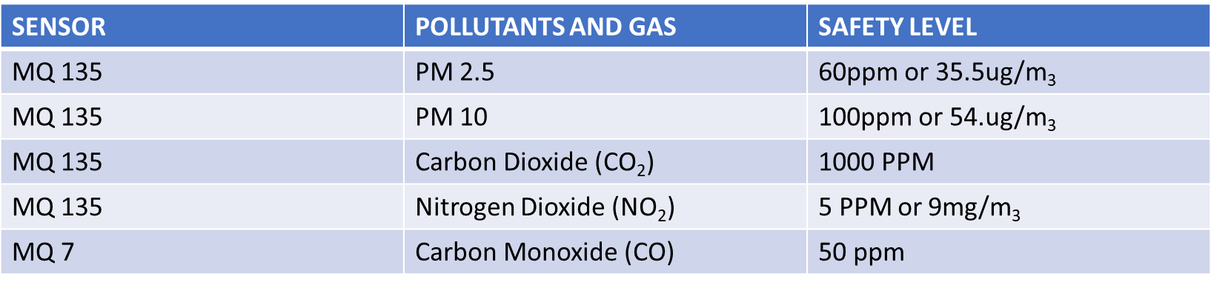

## CHAPTER 4

**Electronic System**

**4.1 Arduino Uno**

The Uno is a microcontroller board based on the ATmega328P. It has 14 digital input/output pins (of which 6 can be used as PWM outputs), 6 analog inputs, a 16 MHz quartz crystal, a USB connection, a power jack, an ICSP header and a reset button.

Pin Configuration

|  |  |  |
| --- | --- | --- |
| **Pin Category** | **Pin Name** | **Details** |
| Power | Vin, 3.3V, 5V, GND | Vin: Input voltage to Arduino when using an external power source.  5V: Regulated power supply used to power microcontroller and other components on the board.  3.3V: 3.3V supply generated by on-board voltage regulator. Maximum current draw is 50mA.  GND: ground pins. |
| Reset | Reset | Resets the microcontroller. |
| Analog Pins | A0 – A5 | Used to provide analog input in the range of 0-5V |
| Input/Output Pins | Digital Pins 0 - 13 | Can be used as input or output pins. |
| Serial | 0(Rx), 1(Tx) | Used to receive and transmit TTL serial data. |
| External Interrupts | 2, 3 | To trigger an interrupt. |
| PWM | 3, 5, 6, 9, 11 | Provides 8-bit PWM output. |
| SPI | 10 (SS), 11 (MOSI), 12 (MISO) and 13 (SCK) | Used for SPI communication. |
| Inbuilt LED | 13 | To turn on the inbuilt LED. |
| TWI | A4 (SDA), A5 (SCA) | Used for TWI communication. |
| AREF | AREF | To provide reference voltage for input voltage. |

Arduino is a programmable circuit board in which we can set command and we can program the Arduino for the desired feedback from the board.

**Arduino Uno** is a microcontroller board based on 8-bit ATmega328P microcontroller. Along with ATmega328P, it consists other components such as crystal oscillator, serial communication, voltage regulator, etc. to support the microcontroller. Arduino Uno has 14 digital input/output pins (out of which 6 can be used as PWM outputs), 6 analog input pins, a USB connection, A Power barrel jack, an ICSP header and a reset button.

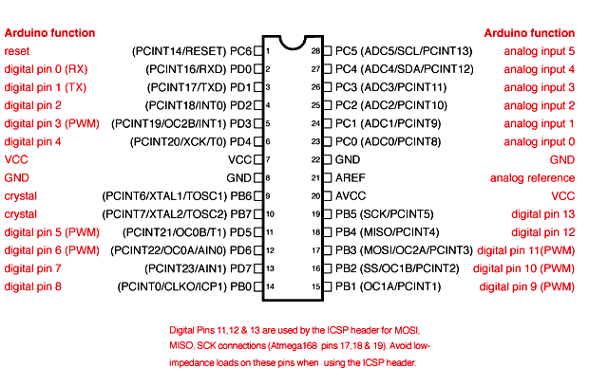

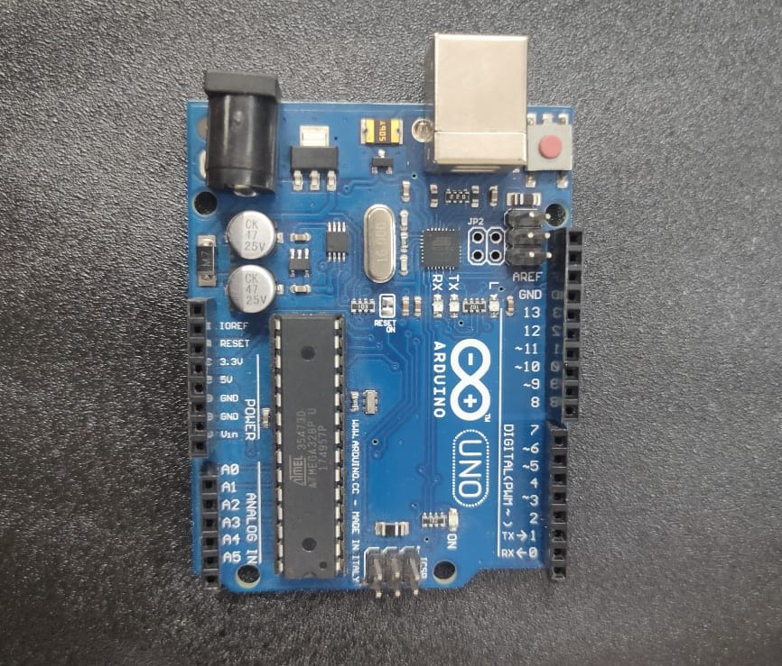

**4.2 MQ 7 Sensor**

This is a simple-to-use Carbon Monoxide (CO) sensor, suitable for sensing CO concentrations in the air. The MQ-7 can detect CO-gas concentrations anywhere from 10 to 500ppm.

This sensor has a high sensitivity and fast response time. The sensor's output is an analog resistance. The drive circuit is very simple; all you need to do is power the heater coil with 5V, add a load resistance, and connect the output to an ADC.

**Pin Configuration**

|  |  |  |
| --- | --- | --- |
| **Pin No:** | **Pin Name:** | **Description** |
| **For Module** | | |
| 1 | Vcc | This pin powers the module, typically the operating voltage is +5V |
| 2 | Ground | Used to connect the module to system ground |
| 3 | Digital Out | You can also use this sensor to get digital output from this pin, by setting a threshold value using the potentiometer |
| 4 | Analog Out | This pin outputs 0-5V analog voltage based on the intensity of the gas |
| **For Sensor** | | |
| 1 | H -Pins | Out of the two H pins, one pin is connected to supply and the other to ground |
| 2 | A-Pins | The A pins and B pins are interchangeable. These pins will be tied to the Supply voltage. |
| 3 | B-Pins | The A pins and B pins are interchangeable.   One pin will act as output while the other will be pulled to ground. |

Features of the MQ 7 Sensor

1. Operating Voltage is +5V.
2. Can be used to Measure or detect LPG, Alcohol, Propane, Hydrogen, CO and even methane.
3. Analog output voltage: 0V to 5V.
4. Digital Output Voltage: 0V or 5V (TTL Logic).
5. Preheat duration 20 seconds.
6. Can be used as a Digital or analog sensor.
7. The Sensitivity of Digital pin can be varied using the potentiometer.

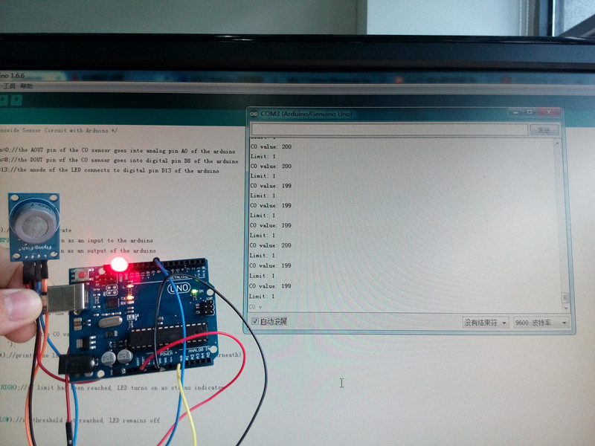

**4.3 MQ 135 Sensor**

The MQ-135 Gas sensors are used in air quality control equipment's and are suitable for detecting or measuring of NH3, NOx, Alcohol, Benzene, Smoke, CO2. The MQ-135 sensor module comes with a Digital Pin which makes this sensor to operate even without a microcontroller and that comes in handy when you are only trying to detect one particular gas.

**Pin Configuration**

|  |  |  |
| --- | --- | --- |
| Pin No: | Pin Name: | Description |
| For Module | | |
| 1 | Vcc | Used to power the sensor, Generally the operating voltage is +5V. |
| 2 | Ground | Used to connect the module to system ground. |
| 3 | Digital Out | You can also use this sensor to get digital output from this pin, by setting a threshold value using the potentiometer. |
| 4 | Analog Out | This pin outputs 0-5V analog voltage based on the intensity of the gas. |
| For Sensor | | |
| 1 | H -Pins | Out of the two H pins, one pin is connected to supply and the other to ground |
| 2 | A-Pins | The A pins and B pins are interchangeable. These pins will be tied to the Supply voltage. |
| 3 | B-Pins | 1. A pins and B pins are interchangeable. One pin will act as output while the other will be pulled to ground. |

**Features of MQ 135 Sensor**

1. Wide detecting scope.
2. Fast response and High sensitivity.
3. Stable and long life.
4. Operating Voltage is +5V.
5. Detect/Measure NH3, NOx, alcohol, Benzene, smoke, CO2, etc.
6. Analog output voltage: 0V to 5V.
7. Digital output voltage: 0V or 5V (TTL Logic).
8. Preheat duration 20 seconds.
9. Can be used as a Digital or analog sensor.
10. The Sensitivity of Digital pin can be varied using the potentiometer.

**4.4 DHT 11 SENSOR**

The **DHT11 sensor** can either be purchased as a sensor or as a module. Either way, the performance of the sensor is same. The sensor will come as a 4-pin package out of which only three pins will be used whereas the module will come with three pins as shown above.

**Pin Configuration**

|  |  |  |
| --- | --- | --- |
| **No:** | **Pin Name** | **Description** |
| **For DHT11 Sensor** | | |
| 1 | Vcc | Power supply 3.5V to 5.5V |
| 2 | Data | Outputs both Temperature and Humidity through serial Data |
| 3 | NC | No Connection and hence not used |
| 4 | Ground | Connected to the ground of the circuit |
| **For DHT11 Sensor module** | | |
| 1 | Vcc | Power supply 3.5V to 5.5V |
| 2 | Data | Outputs both Temperature and Humidity through serial Data |
| 3 | Ground | Connected to the ground of the circuit |

**Features of DHT 11 Sensor**

1. Operating Voltage: 3.5V to 5.5V
2. Operating current: 0.3mA (measuring) 60uA (standby)
3. Output: Serial data
4. Temperature Range: 0°C to 50°C
5. Humidity Range: 20% to 90%
6. Resolution: Temperature and Humidity both are 16-bit
7. Accuracy: ±1°C and ±1%

**4.5 LCD SCREEN (16*2)**

LCD modules are very commonly used in most embedded projects, the reason being its cheap price, availability and programmer friendly. Most of us would have come across these displays in our day today life, either at PCO’s or calculators. The appearance and the pinouts have already been visualized above now let us get a bit technical.

**Pin Configuration**

|  |  |  |
| --- | --- | --- |
| **Pin No:** | **Pin Name:** | **Description** |
| 1 | Vss (Ground) | Ground pin connected to system ground |
| 2 | Vdd (+5 Volt) | Powers the LCD with +5V (4.7V – 5.3V) |
| 3 | VE (Contrast V) | Decides the contrast level of display. Grounded to get maximum contrast. |
| 4 | Register Select | Connected to Microcontroller to shift between command/data register |
| 5 | Read/Write | Used to read or write data. Normally grounded to write data to LCD |
| 6 | Enable | Connected to Microcontroller Pin and toggled between 1 and 0 for data acknowledgement |
| 7 | Data Pin 0 | Data pins 0 to 7 forms a 8-bit data line. They can be connected to Microcontroller to send 8-bit data.  These LCD’s can also operate on 4-bit mode in such case Data pin 4,5,6 and 7 will be left free. |
| 8 | Data Pin 1 |  |
| 9 | Data Pin 2 |  |
| 10 | Data Pin 3 |  |
| 11 | Data Pin 4 |  |
| 12 | Data Pin 5 |  |
| 13 | Data Pin 6 |  |
| 14 | Data Pin 7 |  |
| 15 | LED Positive | Backlight LED pin positive terminal |
| 16 | LED Negative | Backlight LED pin negative terminal |

**Features of LCD Screen**

1. Operating Voltage is 4.7V to 5.3V
2. Current consumption is 1mA without backlight
3. Alphanumeric LCD display module, meaning can display alphabets and numbers
4. Consists of two rows and each row can print 16 characters.
5. Each character is build by a 5×8 pixel box.
6. Can work on both 8-bit and 4-bit mode.
7. It can also display any custom generated characters.
8. Available in Green and Blue Backlight.

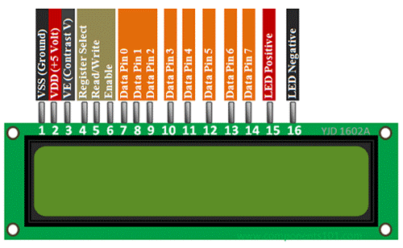

CHAPTER 5

**MECHANICAL COMPONENTS**

5.1. Air cabin

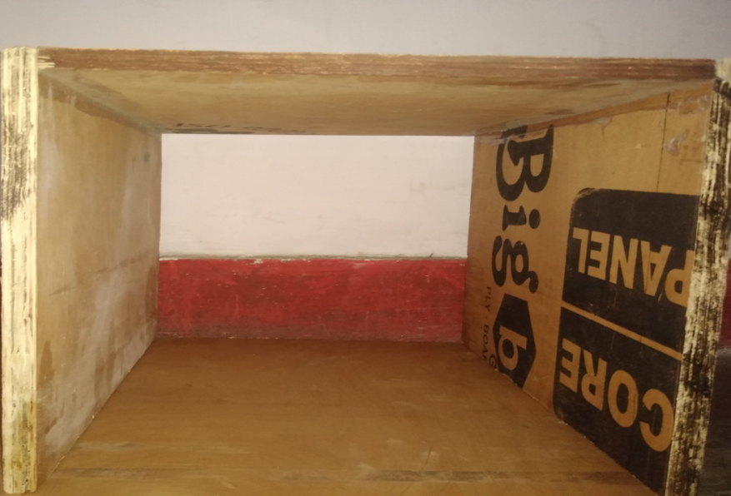

Dimension: 40*32.2*38 cm

5.2. Motor

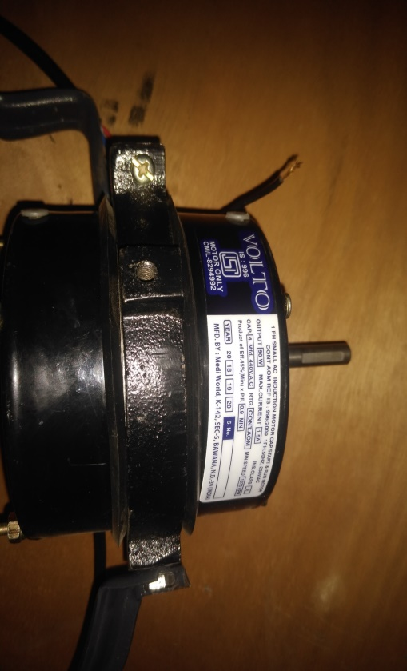

5.3. Centrifugal fan

A centrifugal fan is a mechanical device for moving air or other gases. The terms "blower" and "squirrel cage fan", (because it looks like a hamster wheel), are frequently used as synonyms. These fans increase the speed and volume of an air stream with the rotating impellers. Centrifugal fans use the kinetic energy of the impellers to increase the volume of the air stream, which in turn moves them against the resistance caused by ducts, dampers and other components. Centrifugal fans displace air radially, changing the direction (typically by 90°) of the airflow. They are sturdy, quiet, reliable, and capable of operating over a wide range of conditions. Centrifugal fans are constant displacement devices or constant volume devices, meaning that, at a constant fan speed, a centrifugal fan moves a relatively constant volume of air rather than a constant mass. This means that the air velocity in a system is fixed even though the mass flow rate through the fan is not. The centrifugal fan is one of the most widely used fans. Centrifugal fans are by far the most prevalent type of fan used in the HVAC industry today. They are often cheaper than axial fans and simpler in construction. They are used in transporting gas or materials, ventilation systems for buildings and vehicles. They are also well-suited for industrial processes and air pollution control systems.



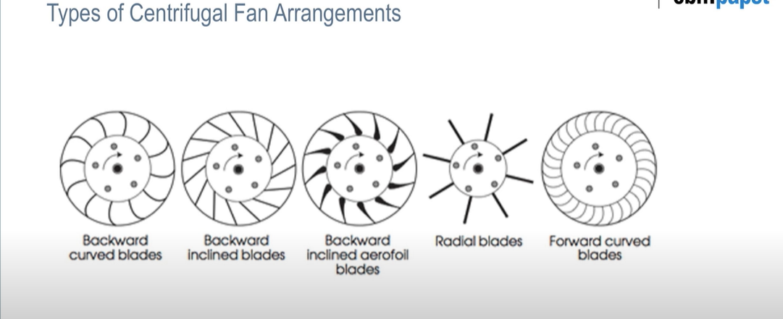

5.4. **HEPA (High Efficiency Particulate Air) Filters**

High efficiency particulate air (HEPA), originally called high-efficiency particulate absorber but also sometimes called high-efficiency particulate arresting or high-efficiency particulate arrestance, is a type of filter. These filters are made up of borosilicate fibers or plastic fibers. Filters meeting the HEPA standard have many applications, including use in medical facilities, automobiles, aircraft and homes. To qualify as HEPA by industry standards, an air filter must remove (from the air that passes through) 99.97% of particles that have a size greater-than-or-equal-to 0.3 μm. In the air purifier this filter should have 2nd position as this filter is made for small particles and these filters are expensive too. As because of pre filter this filter has a clogging time of 3 months after which this filter has to be changed.

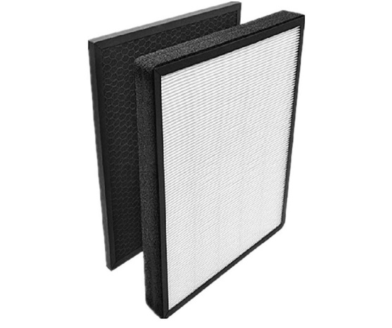

CHAPTER 6

DESIGN OF PURIFIER

* 1. Calculation of Parameters

6.1.1 Volume of room

The air purifier is to be designed according to the cleaning space.

|  |  |
| --- | --- |
| Volume of Bedroom | 15.8*15.8*10 (in feet)(L*B*H) |

6.1.2 Filter Size

As per the availability of different size of filter in market we choose the most economic and easy to install filters.

|  |  |
| --- | --- |
| Filter | Dimensions |
| Pre filter | 1.14*0.91(in feet) |
| Activated carbon filter | 1.14*0.91(in feet) |
| HEPA filter | 1.14*0.91(in feet) |

6.1.3 Air changes per hour

Air changes per hour, or air change rate, abbreviated ACH or ACPH, is a measure of the air volume added to or removed from a space (normally a room or house) divided by the volume of the space. If the air in the space is either uniform or perfectly mixed, air changes per hour is a measure of how many times the air within a defined space is replaced.

ACPH= (60*Q)/VOL

ACPH = number of air changes per hour; higher values correspond to better ventilation.

Q = Volumetric flow rate of air in cubic feet per minute (cfm),

Vol = Space volume L × W × H, in cubic

ACPH = 6

6.1.4 Fan selection

We have to find the value of discharge so that we can select fan for the purifier.

Where:

Q= (volume*ACPH)/60

Volume of bedroom 15.8*15.8*10(in feet) (l*b*h)

ACPH = 6

Vol of room = 10*10*10

Q= ((15.8*15.8*10) *(6)/60

Q= 250 cfm

Now a fan is selected with 250 cfm and above.

6.2 OVERALL DESIGN

Till this part of the project we found all the filters, appropriate type of centrifugal fan and now we need a cabin for assembly of all these components. For this we made cross section of the cabin square which is according to the filters which are available in the market. To choose the length of the filters we came across many factors to be considered like assembly of all the filters and axial fan, along with the instalment of the relay assembly, sensors and input/output vent space. The cabin is also to be designed by keeping in mind the value of future expansion in our project that could be easily done without any design conflicts.

The CAD design is shown below:

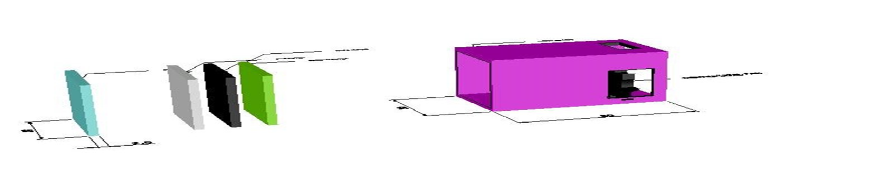

Figure6.1- CAD design (Side View)

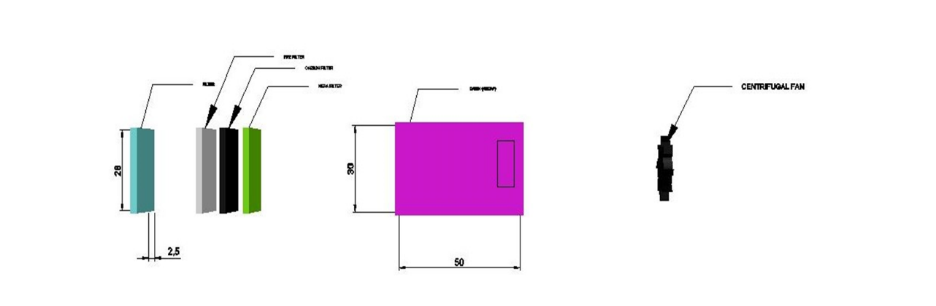

Figure6.2-CAD design (TOP View)

**6.3 Total Expenditure**

|  |  |  |  |
| --- | --- | --- | --- |
| S No. | Components | Quantity | Cost |
| 1. | Ply Wood Board | 1 (7*3) Feet | 800 |
| 2. | Nail (1 inch) | 1 | 20 |
| 3. | Fevicol | 1 | 45 |
| 4. | Door Occupants | 5 | 80 |
| 5. | HEPA Filter | 1 | 2500 |
| 6. | Electric Plug | 1 | 40 |
| 7. | Motor and Fan | 1 | 1700 |
| 8. | Jump Wire | 2 | 250 |
| 9. | DC Power Adapter | 1 | 675 |
| 10. | Arduino Uno | 1 | 500 |
| 11. | MQ 135 | 1 | 150 |
| 12. | MQ 7 | 1 | 140 |
| 13. | DHT 11 | 1 | 130 |
| 14. | LCD Screen (16*2) | 1 | 300 |
| 15. | Jump Wire | 2 | 200 |

TOTAL EXPENDITURE = 7500

CHAPTER 7

CONCLUSION

As we have seen reports given by CPCB and WHO, the AQI levels are going near 800- 900 for PM2.5.As this making a serious concern, a healthy solution is needed because knowingly or unknowingly the pollutants like NOX, PM2.5, PM10 etc. are effecting our body adversely and making our live span shorter and giving hazardous effects to our body.

These pollutants can only be easily captured by filter mechanism .These filters are selected by first finding the particles size that could be present in our cleaning space and then buying the respective filter for that particle size and MERV value. In our project and respective cleaning space we have chosen 4 filters that are pre filter, HEPA filter, activated carbon filter. This combination of filters can remove all the particle ranges from 0.3 micron to 10.0 micron, moreover it can also alter the DNA of the microbiological bacteria. As a whole the air blown out of the purifier is free from all reparable pollutants and fully pure to breathe. Apart from this, the air purifier should be installed by considering the height of the humans inside the room and number of doors/windows in the room as this can decrease the effectiveness of the purifier.

After many researches, we came across a conclusion that a purifier is more required indoors as we spend majority of time in our homes and offices. In these spaces the pollutants and impurities gets entrapped and only way for them is to go into our lungs. So, as a whole we first need an air purifier installed in our home so that our family can be protected by these harmful junk of air we breathe every day.

Many researches are going in this world to decrease the amount of air pollution which are exhausted by energy producing plants and other pollution sources. One of the major researches are on the non-conventional energy resources as these are pollution free.

As air is one of our basic needs for living and the future of this earth will going to compel us to use these air purifiers as it is becoming more like a giant thermal power plant.

REFERENCES

[1] G. Allen, V. A. Us, and U. S. C, “( 12 ) United States Patent ( 45 ) Date of Patent : selectively engagable with the outlet grille for preventing,” vol. 1, no. 12, 2002.

[2] “US4597781.pdf.” .

[3] P. Art, “( 12 ) United States Patent,” vol. 2, no. 12, 2005.

[4] F. Application and P. Data, “( 12 ) United States Patent ( 10 ) Patent No .:,” vol. 2, no. 12, 2016.

[5] I. L. Us, S. Michael, W. Dale, and I. L. Us, “worobienie pe acopera com sen,” vol. 2, 2017.

[6] P. Examiner, D. S. Smith, and H. G. Jarcho, “United States Patent (19),” no. 19, 2000.

[7] K. M. Cronin and N. Mcclennen, “(12) United States Patent,” vol. 1, no. 12, 2003.

[8] C. Park, P. Examiner, and K. Mayekar, “( 12 ) United States Patent,” vol. 2, no. 12, 2008.

[9] O. Lake, “(12) United States Patent,” vol. 1, no. 12, 1969.

[10] T. Oba, N. Matsushita, and K. Suzuki, “(12) United States Patent,” vol. 2, no. 12, 2005.